# C1- S4-THE TRIANGLES

# EXERCICE 1

# 

**Q1 -** What is the pattern?

**Q2 -** Can you find the next row in this triangle?

# EXERCICE 2

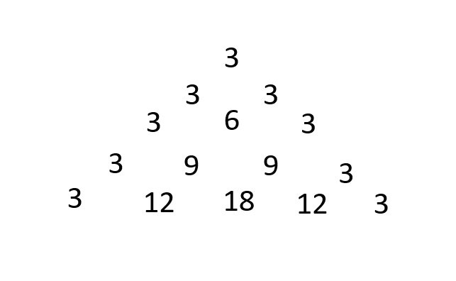

**Q1 -** What is the pattern?

**Q2 -** Can you find the next row in this triangle?